Yellow- Main drop down bars (Welcome, Parish life, Youth Religious Education, and Parish news)
Green- Anything under the main drop bars
Blue- Ministries under the “All Ministries” tab
Home Page

Henri Nouwen’s Intimate Letters Shed Light on his ‘Theology of the Heart’
[Reposted in part from Religion News Service, October 04 – story by John Murawski] (RNS) As one of the 20th century’s pre-eminent...read more
The post Henri Nouwen’s Intimate Letters Shed Light on his ‘Theology of the Heart’appeared first on Henri Nouwen Society.

Executive Director’s Message
Update from Karen Pascal Executive Director, Henri Nouwen Society Dear Friends, I have just returned from a visit to Henri Nouwen’s gravesite...read more
The post Executive Director’s Message appeared first onHenri Nouwen Society.

Prayer Wall
Please pray for
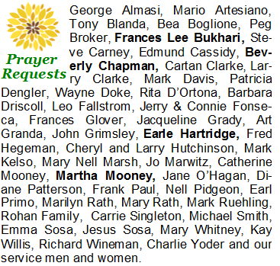
912-638-4287 to leave a prayer request any time day or night. Or, you can submit your prayer request below.

Week at The Church
See our full Calendar →

ST. WILLIAM CATHOLIC CHURCH - ST. SIMONS ISLAND, GA

PASTOR, MSGR. JOHN KENNEALLY
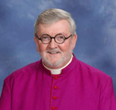
I hope you enjoy our efforts on your behalf. We are always striving to keep you informed of the activities here in our parish. Please review the various drop-down levels in the menus listed across the top of the page.
Call the office with your ideas for improvement.
PASTOR, MSGR. JOHN KENNEALLY
St. William Catholic Church
Saint Simons Island, GA
Welcome (about us)
MSGR. John Kenneally

Msgr. John Kenneally celebrates 45th Ordination Anniversary
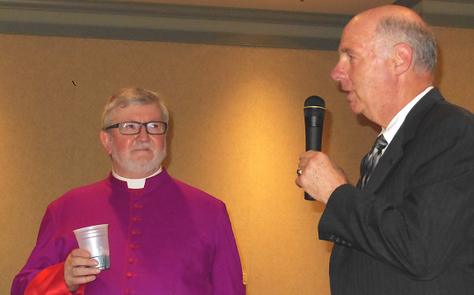A packed house celebrated Msgr. John's 45th Ordination Anniversary in June, 2014.
History

History of Our Church
Catholic presence on St. Simons Island goes back to the 1500's and began as a missionary effort to the local indians.
By 1590, Franciscan Friars had established missions along the southeast coast of Georgia, including one at San Simeon, which the Guale Indians called Mission Asao. However, because of their steadfast belief in the Christian sanctity of marriage, these Franciscans were martyred and the mission destroyed by the Guales in 1597.
After centuries of meeting in private homes for worship, good news came to the Catholic community on St. Simons Island. Through the Catholic Church Extension Society in Brooklyn, New York, a woman had allocated $5,000 for a chapel to be built on the island with two conditions. First, the chapel must be named for her late husband William, and second, an architect would have to be hired for the design. The name was approved, and architect Cormac McGarvey volunteered his services for the project. Now all that was left to do was raise money to purchase the land on which the chapel was to be built.
A card party, held at the County Casino, was organized. With donations of door prizes, ice and cakes from local merchants, $125 was raised through the sale of tickets to the entire community, Catholics and Protestants alike. Fr. Peter McOscar, pastor of St. Francis Xavier in Brunswick, secured additional capital, and the first Frederica Road property was bought from Miss Bonnie Ross. The Faithful had persevered, and their efforts were rewarded when Bishop Michael J. Keyes officially opened the doors of St. William's Chapel in December of 1929. The small chapel stood almost directly across the street from the site of the original mission some 300 years earlier.
Visitors continued to play an important and interesting part in the history of the chapel. Besides donations of many furnishings by generous non-local benefactors (including statues of the Blessed Mother and St. Joseph, Stations of the Cross and the confessional door), the chapel can claim celebrity status also. In the mid-1930's, actress Irene Dunn was a member of one of our Confirmation Classes; vacationing opera star Giovanni Martinelli graced the parishioners with his beautiful voice; and Joe DiMaggio volunteered as an altar server in 1950.
With growth of the parish, the chapel was enlarged to seat 298, and in 1968 St. William acquired parish status and assumed Darien's Nativity Chapel as its mission. It was at this time that the rectory and parish hall were built further south on Frederica Road, the present location. As the parish continued to grow, it was decided to build a larger church on the new property. Bishop Raymond W. Lessard dedicated the new St. William's Church on September 14, 1986.
It is only fitting with such a storied legacy that, in 1992, St. William's was chosen by the Diocese of Savannah to provide a permanent home for the Pilgrim Cross celebrating 500 years of evangelization in the Americas.
In 1996 the Parish Hall was remodeled and expanded to accommodate the increase in parish activities. It is presently made available to many organizations in the community at a modest fee. Stop by or call the office, 912-638-2647, for more information on using our facilities.

Who Was St. William?
William de Donjcon was born to an illustrious family of Nevers, France in the 12th century. Educated by his uncle Peter, Archdeacon of Soissons, William rejected the vanities of the world and devoted himself to exercises of piety and the acquisition of Knowledge.

The San Damiano Cross
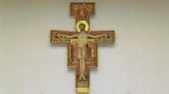
The San Damiano Cross that hangs above our altar is a larger replica of the original that hangs in Santa Chiarra Church in Assisi, Italy.
Painted during the 12th century by an unknown artist in the Umbria district of Italy, the cross hung for many years in a rundown church in San Damiano. As St. Francis was passing by the church, he heard a voice, went inside and knelt to pray before the cross. He then heard the words, "Francis, repair My house." St. Francis' first effort was to repair the church buildings, but eventually he came to realize that God wanted him to build up the lives of His people. The cross is an icon cross - one that contains images of people who played a part in an event.. Therefore, it tells a story. The artist has represented Jesus as both wounded and strong - the crucified and the Risen Christ. There are five major witnesses. On the left are the Blessed Virgin Mary and St. John, to whom Jesus gave his mother at the time of His death. Mary Magdalene, Mary, mother of James, and the centurion are on the right. Minor witnesses on the cross include soldiers and onlookers. The rooster represents the betrayal of Christ, and it is believed that the six figures at the bottom are the patron saints of Umbria. Six angels, three near each hand of Christ, wonder at the event of the crucifixion. At the top of the cross ten more angels are crowded around Christ, welcoming Him as He climbs from the tomb and enters into heaven. Christ is shown fully clothed and carries a cross as a scepter. At the top of the cross, we see the right hand of the Father raising Jesus from the dead and giving Him a blessing for all that He has done. The Latin inscription reads "Jesus of Nazareth, King of the Jews". The original San Damiano Cross was restored in 1938 and was placed for public viewing during Holy Week of 1957.

Staff Members
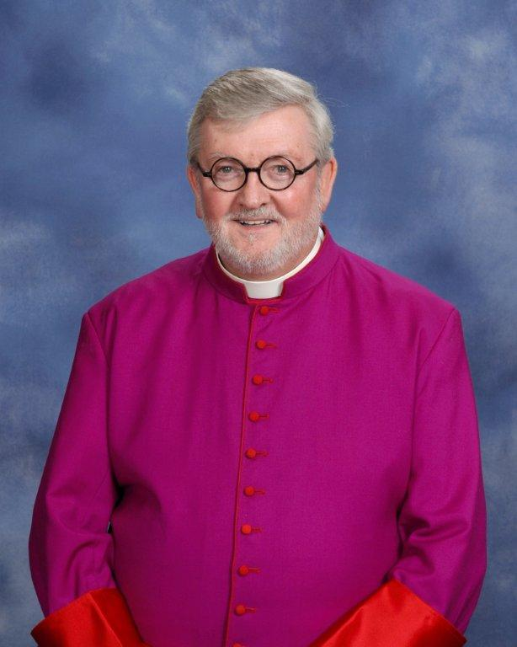  Pastor  Msgr. John Kenneally  (912) 638-2647 | 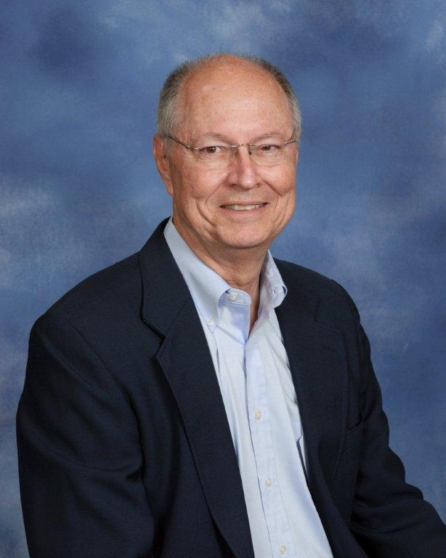  Deacon George Ruehling  (912) 638-2647
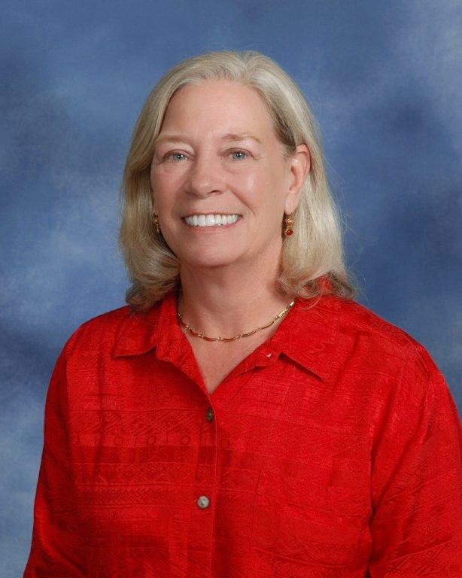
Secretary/Office Mgr
Ms. Jan Roberts
(912) 638-2647

CONTACT US
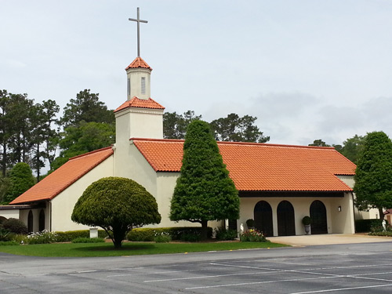
St. William Catholic Church
2300 Frederica Road
Saint Simons Island, GA 31522
Office Phone: 912-638-2647
Office FAX: 912-638-7577
Email: stwilliamschurch@comcast.net

Directions
St. William Catholic Church is located at 2300 Frederica Road on beautiful St. Simons Island.
As you come onto the island, veer left and then continue on Demere Road straight through the three stop lights and turn left at the Round About at the intersection of Demere and Frederica. Go North on Frederica through two traffic lights and the church will be on the right side of the road.
Click to open map ↗

Mass Times

Sunday - Masses at 8am & 10:30am Adoration on Tuesdays from 9am to 6pm in the chapel
Saturday Vigil - Mass at 5:30pm Tuesdays - Mass at 6pm, following adoration.
Daily Mass - Monday - Saturday at 8:15am
Reconciliation - Saturdays from 4:30-5:15pm or by appointment

Our Partners

ITI Marketing, Inc.
1611 Union Street,
Brunswick, GA, 31520 USA
E-mail: info@iti-marketing.com
Telephone: (912) 267-1558
http://www.iti-marketing.com

New Comers (Parish Registration)
If you would like to register for membership at St. William please come by the office OR fill out the online registration form.
Please click on the link below to see a Registration Form in PDF format. After filling out the form, please bring it by the Parish Office any weekday between the hours of 9 am to 12:30 pm and 1:30 pm and 4 pm.

Parish Life (Ministries & ORGS)
Ministry Schedule

Daily Roster Sept-Oct
Ministry Schedule by Ministry for September-October 2016
- Altar Server - September-October
- Daily Schedule - September-October
- Eucharistic Minister Schedule - September-October
- Lector Schedule -September-October
- Usher Schedule -September-October

Rosters by Ministry
- Eucharistic Ministers
- Ushers
- Lectors
- Altar Servers
- Daily

All Ministries
Adoration
The opportunity to spend a half hour or longer in prayer before the Presence of the Blessed Sacrament is offered every Tuesday between 9:00 a.m. – 6:00 p.m. There is a list posted in the vestibule for those who wish to sign up for a specific time of the day; however, everyone is welcome at any hour.

For more information, call Georgia Ann Markley at 638-6381 or Larry Lynch at 638-0148.
Altar Server
Girls and Boys who have received First Communion and are beginning the Fourth Grade are eligible to serve in this ministry.
For more information, please call: Mike Cherne 638-9048 or Holly Diestel 230-9386.

Current Guidelines for Serving
Server Application & Permission Form

March Newsletter
April Newsletter
June Newsletter
July Newsletter
August Newsletter
November Newsletter
December Newsletter
March Newsletter 2014
September Newsletter 2014

Bereavement
The Bereavement Committee provides support to families when a death has occurred. At the time of a death, a committee member contacts the bereaved family to ask if the committee may provide a light luncheon or a reception to follow the Memorial or the Funeral Mass. Committee members are volunteers on an as needed basis and may be asked to provide some type of food and/or to act as hostess for the meal/reception.
For more information, please call Jan Roberts at 638-2647 or Camille Penders at 638-8595.
Bloomers
This group creates the weekly floral arrangements for the church and is also responsible for our fantastic Christmas and Easter decorations.
For more information, please call: Mary Pat Reynolds at 638-8353

Coffee and Doughnuts
Coffee and doughnuts are served after the 8:00 a.m. and 10:30 a.m. Masses every weekend. Arrangements for the refreshments are made by the chairperson and paid for by the parish. Volunteers are responsible for picking up the refreshments, making coffee, setting up the tables, and cleaning up.
For more information, please call RaeAnn Allen at (404) 791-1043.
Council of Catholic Women (CCW)
The Council of Catholic Women acts through its affiliated organizations to support, empower and educate all Catholic women in spirituality, leadership and service. Activities include a Wine & Cheese Social, Fall Bazaar, Advent Luncheon, Spiritual Retreat, Adopt-a-Seminarian, and the Divine Mercy Novena. The CCW sponsors the Sew and So Club, a group of ladies who meet to quilt, make baby bonnets and rosaries. The events sponsored by the Council provide the funds for donations to local and diocesan charities. CCW meets the second Tuesday of September through May at 7:00 p.m.
For more information, please call Claire Kempton at 638-3820 or Laura Nies at 638-1991.
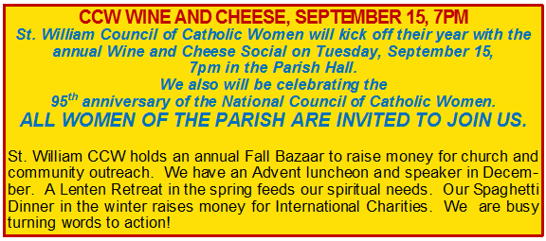
2015-2016 Membership Flyer
Divine Mercy Novena
Through this devotion, Christ's limitless mercy is opened up for those who pray the novena from Good Friday through Mercy Sunday, go to confession in immediate preparation for Mercy Sunday, and go to communion on that day.
For more information, please call Norma McIntyre at 279-0526.
First Saturday
This group meets in the chapel the first Saturday of each month at 8:45am, after Daily Mass, to pray and to honor the Immaculate Heart of Mary through reparation for the sins of mankind.
For more information, please call Norma McIntyre at 279-0526.
Hospitality Committee
This committee is in charge of planning and coordinating many special parish events in order to form a bond of friendship among all parish members. Sponsored events include St. Nicholas Party, St. Patrick’s Day Celebration, Deanery Luncheons, Confirmation Reception, RCIA Reception, Parish Picnic, First Eucharist Reception, High School Graduate Breakfast, Oktoberfest, and a Christmas Party for committee members.
This committee meets on Mondays at 5:30 p.m. as needed, generally two or three times before an event and as announced in the weekly bulletin.
For more information, please call Sue Kilchenstein at 634-2811.
Marian Movement of Primetiers (includes Marian movement of Priest and Primetimers)
Marian Movement of Priest
The origin of the MMP stems from a simple and interior inspiration given to Fr. Don Stefano Gobbi in 1972. He was to have confidence in the Immaculate Heart of Mary, and she would use him as an instrument to gather all priests who accept her invitation to consecrate themselves to her, to be strongly united to the Pope and the Church united with him, and to bring the faithful into the secure refuge of her motherly heart. The MMP meets on Mondays at 8:35 a.m. in the Chapel.
For more information, please call Norma McIntyre at 279-0526.
Primetimers
Primetimers is a social organization with no dues and is open to all members of St. William over the age of 50 and their friends. Meetings and covered dish luncheons are held the first Tuesday of the month at 11:30am, September through May, in the Parish Hall. Notices of the meetings are always in the bulletin and announcements. If you have any questions, please call Valerie Kehoe (638-3919) or Laura Nies (638-1991).
Music Ministry
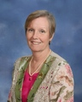
Kate Hamer, Director of Music, shown above, leads the adult choir at Mass as well as the Bell Choir. This talented lady is active in community wide performances.
St. William catholic Church is fortunate to have many talented members who give willingly of their talent for the glory of God and the benefit of their fellow members. Two excellent examples are: Lois Richter and Beverly Fetter, our organists, shown below.
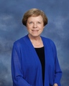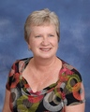
Liturgical music is an exacting and demanding enterprise. Through the leadership of Kate Hamer, Director, the many talents and musical skills of parishioners have been blended into choirs that produce soul stirring experiences week after week at Mass.
Click here for link to www.stwilliammusic.org
(Picture not included)
St. William Choir
(Picture not included)
St William Bell Choir
Outreach

Haiti - Parish Twinning
St. Joseph Catholic Church, in Côtes-de-Fer, Haiti is the sister parish of St. William Catholic Church on St. Simons Island. Fr. Jude is the pastor and is a young, energetic and personable priest, born and raised in Haiti. Read More…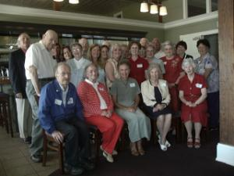

St. Vincent DePaul
When You Give to Your Brother You Give to Me - St. Vincent DePaul Society. The society is an international Catholic organization committed to helping those in need. Our Glynn County conference manages outreach efforts from our thrift store ... Read More…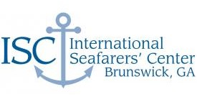

Int'l Seafarers Center This charity is operated by the Brunswick Port Society. Since 1982, it has provided a hospitable refuge for seafarers from more than 70 countries. Read More…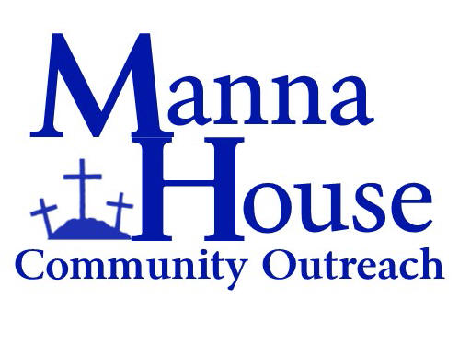

Manna House
This charity provides meals on a daily basis in Brunswick. Volunteers help prepare and serve the lunches. Read More…
Right to life
The Glynn County Chapter of Georgia Right to Life is a non-denominational, ecumenical organization concerned about human life from the moment of conception to natural death. Programs include the “Together for Life” program and the prayer rally held in January on the anniversary of the Roe v. Wade Supreme Court decision.
For more information, please call Wiltz Bernard at 230-2404.

Youth
Creed

Creed Family Fun Video
Read More…

KG to 5th NEWS, FORMS, ANNOUNCEMENTS!
The forms below may be downloaded and completed at home, but please bring with you to register. Additional forms are available from the offices in the parish hall. There is a fee of $35 per child for Creed with an additional fee of $30 for First Reconciliation/Eucharist preparation. Read the Photo & Video release form, and then place an X in the appropriate box on the registration form. If you have any questions, please contact Nancy Power at 638-2651. Kindergarten through 5th Grade students meet on Sundays from 9:00am – 10:15am.

Registration Form
Sacrament Registration Form
Photo-Video Release
Print these forms, fill them out, and take to Mrs. Power in the parish hall.
CReeD calendar
Prayers and Responses to Learn

Life Teen (Youth Ministry)
St. William Parish
Sundays from 5:00-7:00 PM
Our 6th -8th grade students meet Sunday evenings from 5:00-6:00pm.
Nights combine classroom instructions with fun activities to educate middle students in the catholic faith while fostering a strong sense of Christian community.
Diocesan guidelines require two consecutive years of intentional catchesis in preparation for the sacrament of Confirmation. The curriculum facilitates this preparation culminating in the in the reception of Confirmation by our 8th Grade students.
At 6:00pm, 9-12th grade students meet.
The evening provides an atmosphere where high school students can come together to learn and grow in the faith. In addition to Catholic teaching, we offer opportunities for Christian service and fellowship, prayer and liturgy, and social outings throughout the year.
On the second Sunday of each month (school year), we will have Youth mass at 5:00pm followed by a family dinner in the parish hall.
Parents volunteer and partner with one another to sign up and prepare, serve and clean up the meal.
Our students are very active in the local community. Some of our service projects include the Brunswick Mission, The Helping Hugs fundraiser, Night the lights of magnolia Manor, The ‘Soup’er Bowl of Caring, and much more!
Please contact Powernancy@comcast.net or (912)638-2651 for more information on classes or to inquire about our students’ service projects.

Youth Formation FORMS
Click On Forms Below
- 2016-2017 Confirmation Registration Form
- 2016-2017 Youth Registration Form
2016-2017 Field Trip & Photo Release Form
Youth Events
(input youth events here)

Religious Education
Adult Bible study
Adult Bible Study classes meet each Sunday at 9:10am, in the library in the parish hall.
For more information, contact Tom McIntyre at (912) 279-0526.

RCIA
Rite of Christian Initiation of Adults (RCIA)
The RCIA classes are open to those interested in exploring the Catholic way of life, to Catholics wishing to return to the active practice of their faith and to adult Catholics who have not celebrated the Sacrament of Confirmation.
The RCIA participants begin their journey in the fall meet weekly until Pentecost. Classes are part lecture and part discussion where the teachings of the Church and the power of her liturgy are explored and the meaning of both in the daily lives of those making the journey are discovered.
Tuesday Morning Women’s Study Group
(new group)

Parish News
Weekly Bulletin
(link to the weekly Bulletin)
Newsletter
(link to monthly Newsletter)
Monthly Calendar
(link to monthly Calendar)

